|  |  |
| --- | --- |
| TITLE | IOT Based Safety Gadget For Child Safety Monitoring And Notiﬁcation |
| DOMAIN NAME | INTERNET OF THINGS |
| TEAM ID | PNT2022TMID01821 |
| TEAM LEADER NAME | SABARINATHAN G |
| TEAM MEMBER NAME | PATHMALOSHAN C  PRANEETH R  RITHIK M |

IBM CLOUD SERVICES

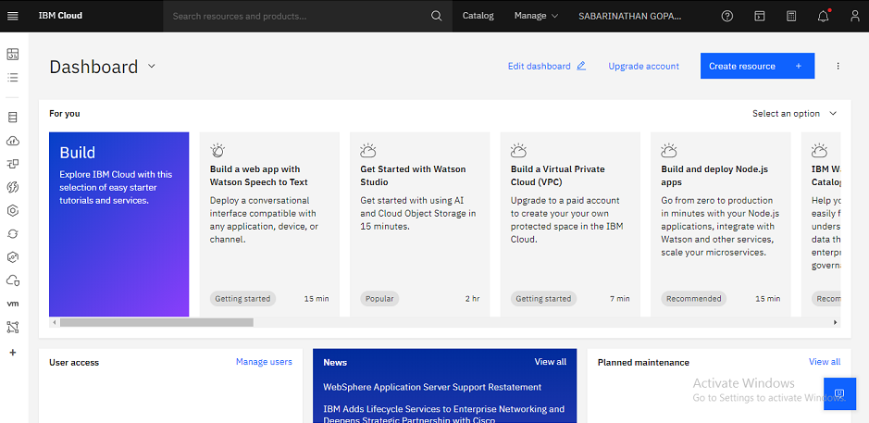

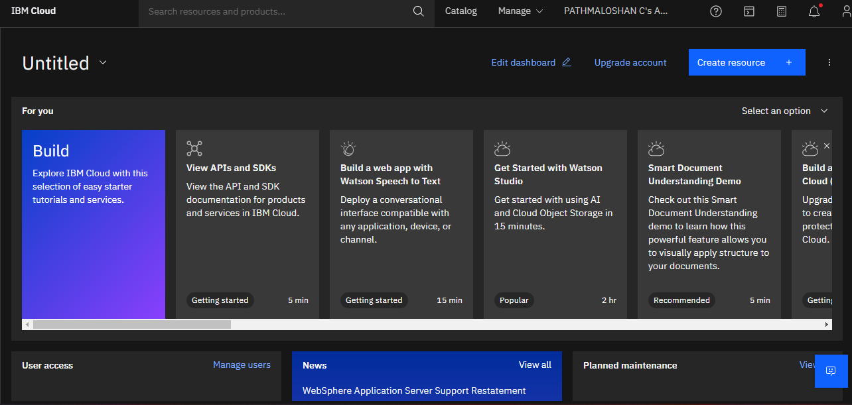

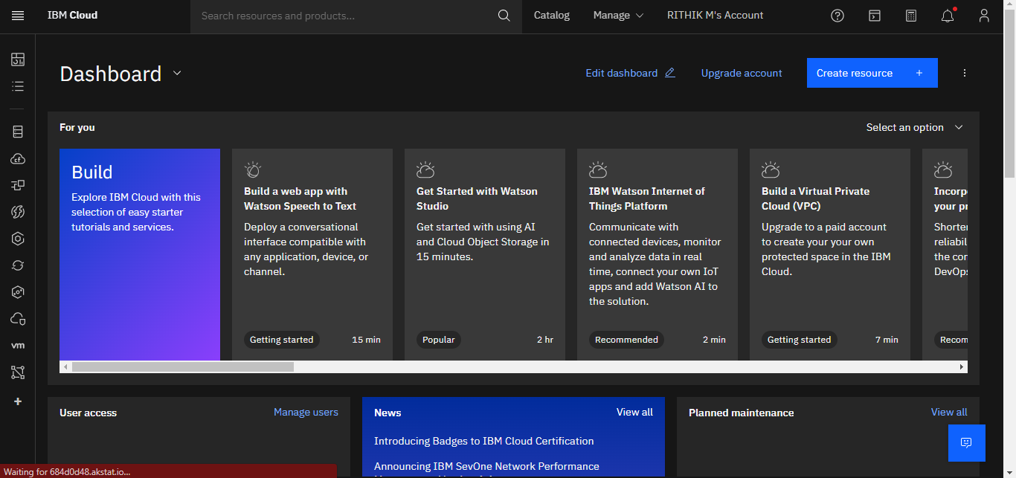

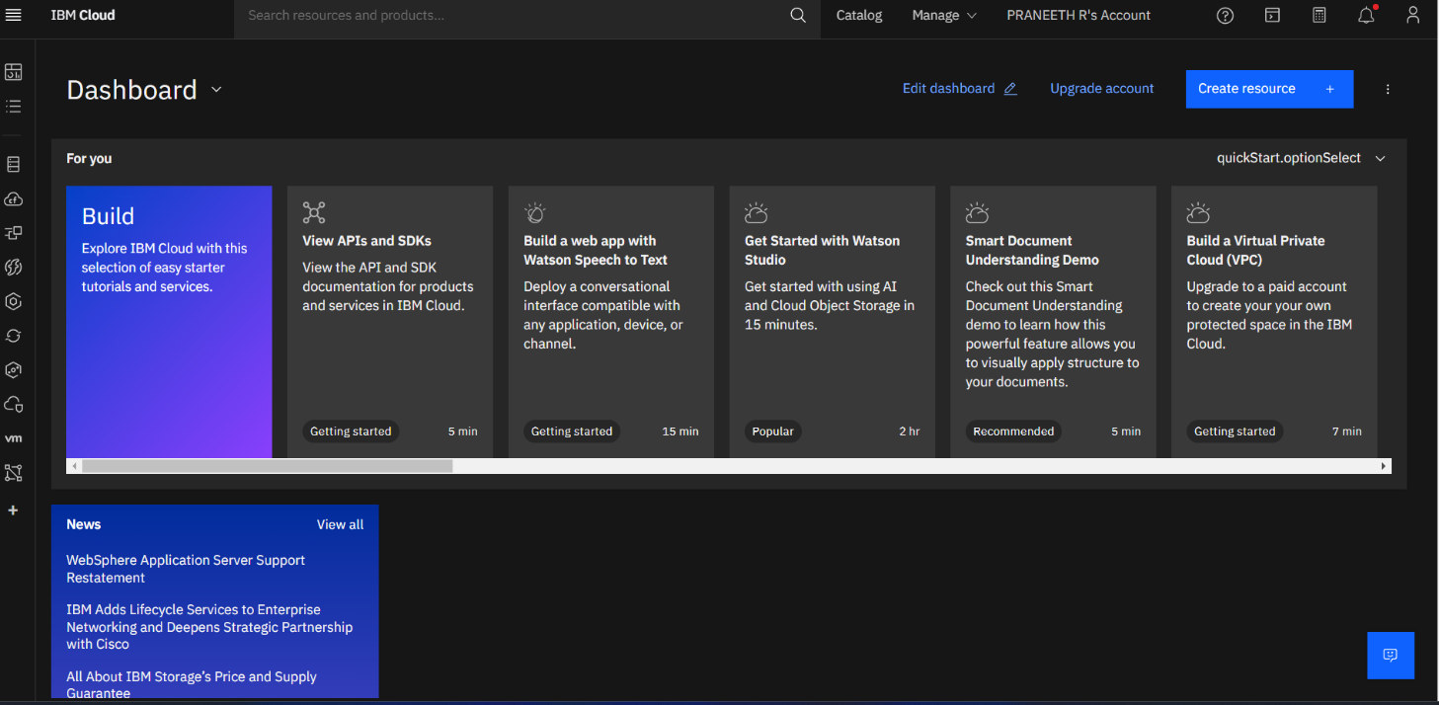

I